1. What is the difference between combinational and sequential circuits?

The output of a combinational circuit is only dependent on the input. You can create a truth table for a combinational circuit.

The output of a sequential circuit is dependent on the input as well as the clock signal and the previous state of the circuit. It has an added notion of memory. You need an excitation table to represent these circuits.

2. Draw a CMOS equivalent gate for NAND, using an AND gate, and an INVERTER.

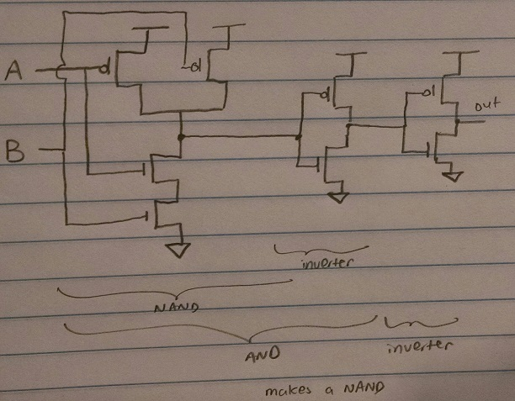

Drawing from the DigitalLogic.pdf in resources, p.54 for inverter and p.57 for AND gate

3. Draw the CMOS equivalent gate for NOR, using only 4 transistors.

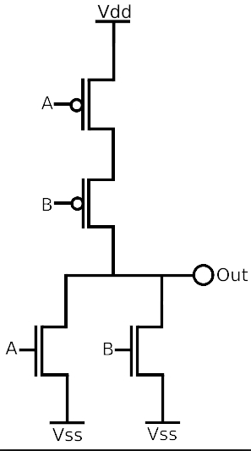

Here Vdd = 1, and Vss = 0. Notice the duality between the NOR and NAND circuits. (Series becomes parallel and parallel becomes series).

4. Draw the CMOS equivalent to a 2 input to 1 output (2:1) multiplexer.

Base it on the gate form of 2:1 mux

A

S

B

C

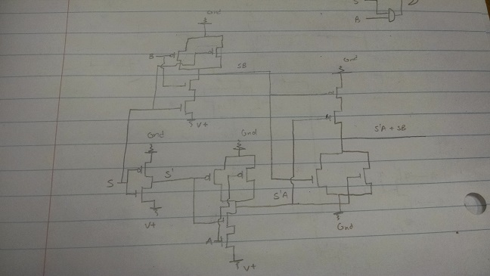

^ Don’t do the “pull up from ground” thing. Apparently, the professor says it’s wrong. I just based this off the wrong NAND diagram from the other student lol.

5. Convert the following binary numbers in decimal: 00101110, 11110101, 11010100. Assume that the numbers are sign-and-magnitude, ones complement, and twos complement.

|  |  |  |  |
| --- | --- | --- | --- |
|  | 00101110 | 11110101 | 11010100 |
| S & M | 46 | -117 | -84 |
| 1’s complement | 46 | -10 | -43 |
| 2’s complement | 46 | -11 | -44 |

6. How is the decimal number 215 represented, in hexidecimal, octal, and binary?

|  |  |
| --- | --- |
| Decimal | 215 |
| Binary | 11010111 |
| Octal | 327 |
| Hex | D7 |

7. Is it true that (ABC)' = A' + B' + C'? Show by means of a truth table.

|  |  |  |  |  |  |  |  |  |
| --- | --- | --- | --- | --- | --- | --- | --- | --- |
| A | B | C | A’ | B’ | C’ | A’+B’+C’ | ABC | (ABC)’ |
| 0 | 0 | 0 | 1 | 1 | 1 | 1 | 0 | 1 |
| 0 | 0 | 1 | 1 | 1 | 0 | 1 | 0 | 1 |
| 0 | 1 | 0 | 1 | 0 | 1 | 1 | 0 | 1 |
| 0 | 1 | 1 | 1 | 0 | 0 | 1 | 0 | 1 |
| 1 | 0 | 0 | 0 | 1 | 1 | 1 | 0 | 1 |
| 1 | 0 | 1 | 0 | 1 | 0 | 1 | 0 | 1 |
| 1 | 1 | 0 | 0 | 0 | 1 | 1 | 0 | 1 |
| 1 | 1 | 1 | 0 | 0 | 0 | 0 | 1 | 0 |

It’s De Morgan’s.

8. Is a 3-INPUT NAND gate the same as a simple cascade of two 2-INPUT NAND gates? Show why or why not.

Nope:

|  |  |
| --- | --- |
| 3-input NAND gate | two 2-input NAND gates |
| (ABC)’ | ((AB)’(C))’ |
| A’ + B’ + C’ | (AB)’’+ C’ |
| (AB)’ + C’ | (AB) + C’ |

9. Simplify the following Boolean functions, using 3-variable maps: a) F(x, y, z) = Σm(0, 2, 6, 7). b) F(A, B, C) = Σm (0, 2, 3, 4, 7)

1. SOP(0,2,6,7)

|  |  |  |  |  |
| --- | --- | --- | --- | --- |
| **C \ AB** | **00** | **01** | **11** | **10** |
| **0** | 1 | 1 | 1 |  |
| **1** |  |  | 1 |  |

F = A’C’ + AB

1. SOP(0,2,3,4,7)

|  |  |  |  |  |
| --- | --- | --- | --- | --- |
| **C \ AB** | **00** | **01** | **11** | **10** |
| **0** | 1 | 1 |  | 1 |
| **1** |  | 1 | 1 |  |

F = A’C’ + BC + B’C’

10. Draw the CMOS circuit for (9)

1. F = A’C’ + AB

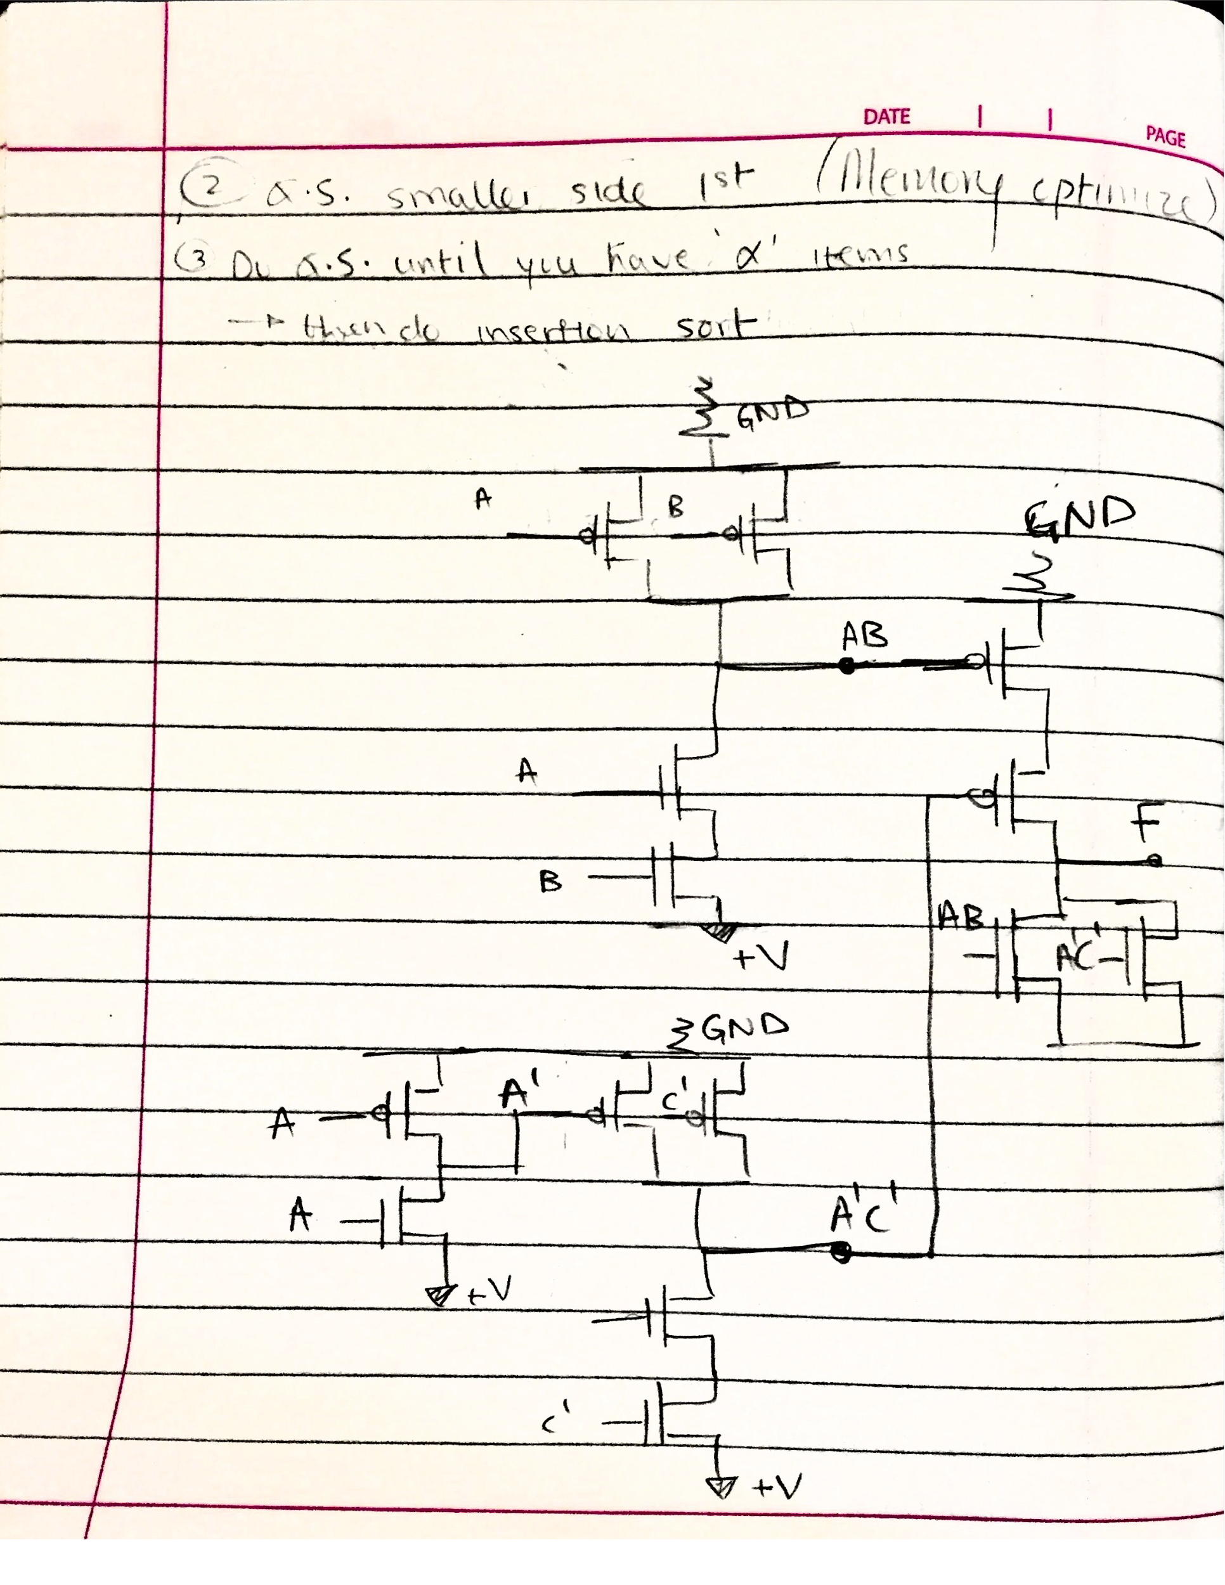

There are 3 parts to this circuit. The first is the top left. It is a CMOS AND circuit that produces AB. The bottom left is again the CMOS AND circuit that produces A’C’. I added an inverting circuit at the bottom left to show how you would get A’ from A. And the last part is all the way on the right. It is a CMOS OR circuit that produces F.

1. F = A’C’ + BC + AB’C’

tl;dr

11. Simplify the following Boolean function F, together with the don't-care conditions d. Draw out the final circuit.

a) F (x, y, z) = **Σ** m(0, 1, 2, 4, 5); d(x, y, z) = **Σ** m (3, 6, 7).

b) F (A, B, C, D) = **Σ** m(1, 3, 5, 7, 9, 15); d(x, y, z) = **Σ** m (4, 6, 12, 13).

1. SOP (0,1,2,4,5). d = (3,6,7)

|  |  |  |  |  |
| --- | --- | --- | --- | --- |
| C\AB | 00 | 01 | 11 | 10 |
| 0 | 1 | 1 | x->1 | 1 |
| 1 | 1 | x->1 | x->1 | 1 |

F = Always true

X

out

1. SOP (1,3,5,7,9,15). d = (4,6,12,13)

|  |  |  |  |  |
| --- | --- | --- | --- | --- |
| CD\AB | 00 | 01 | 11 | 10 |
| 00 |  | x->0 | x->0 |  |
| 01 | 1 | 1 | x->1 | 1 |
| 11 | 1 | 1 | 1 |  |
| 10 |  | x->0 |  |  |

F = A’D + BD + C’D

A

D

C

B

12. Implement the circuits from (11) using only NAND gates. Show you convert the original circuits into NAND gates progressively.

Guide on NAND equivalencies <https://en.wikipedia.org/wiki/NAND_logic>

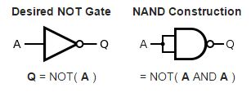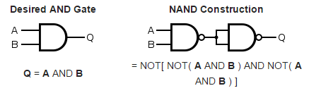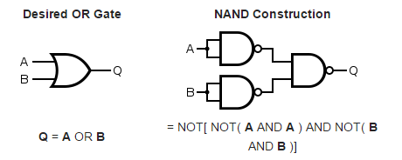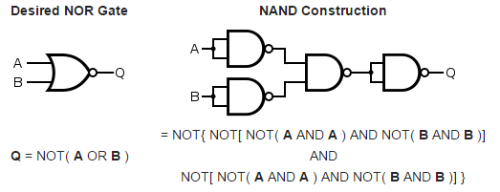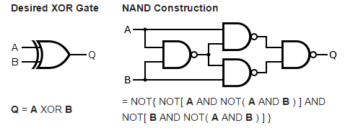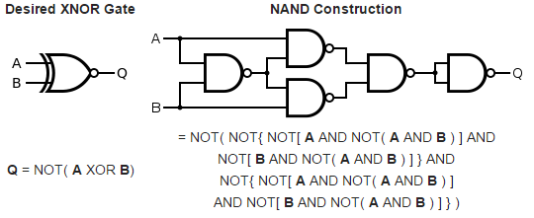\

1. 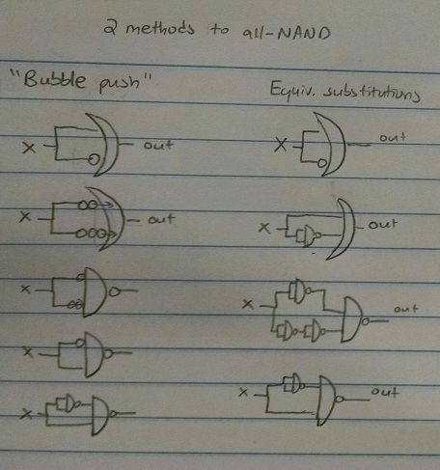

(b) 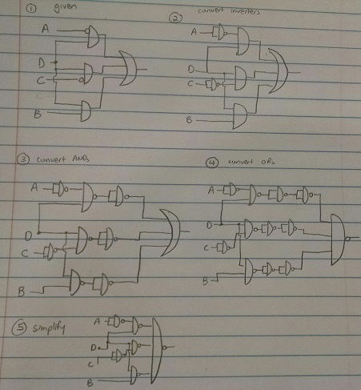

13. Implement the following Boolean function F, together with the don't-care conditions d, using no more than three NOR gates. F(A, B, C, D) = **Σ** m(0, 1, 9, 11); d(x, y, z) = **Σ** m(2, 8, 10, 14, 15).

Guide to NOR equivalencies <https://en.wikipedia.org/wiki/NOR_logic>

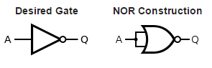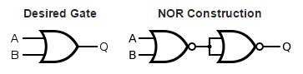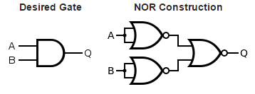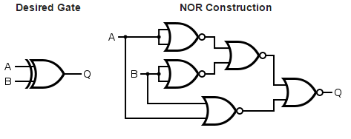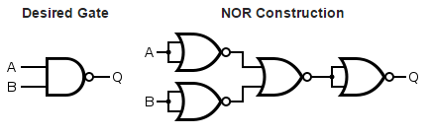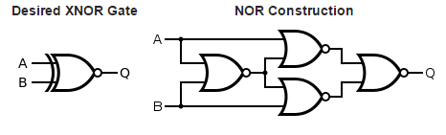

|  |  |  |  |  |
| --- | --- | --- | --- | --- |
| CD\AB | 00 | 01 | 11 | 10 |
| 00 | 1 |  |  | x->1 |
| 01 | 1 |  |  | 1 |
| 11 |  |  | x->1 | x->1 |
| 10 | x->0 |  | x->1 | 1 |

F = AC + B’C’

A

C

B

A

C

B

bubble push

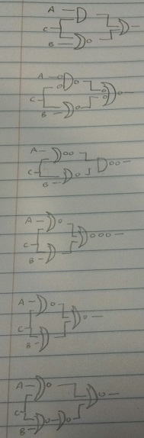

Whelp, that’s down to four NORs, don’t know if this can be reduced further to three NORs... maybe the SOP itself isn’t the most minimal it can be.

14. Design a combinatorial circuit that converts a 4-bit gray code (look at your class notes to see what this is) to a 4-bit binary number. Implement the circuit using XOR gates.

Gray code means only 1 bit changes at a time. We see this when making K-Maps: the top row of the k-map is always 00,01,11,10 instead of a sequential 00,01,10,11.

Complete solution here:

http://wwwcourses.sens.buffalo.edu/mae576/ASSIGNMENTS/mini_assignment4_solution.pdf

XOR Solution:

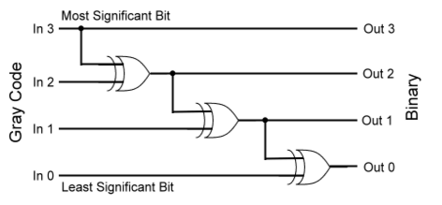

XOR Algorithm:

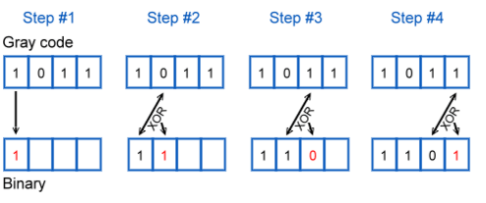

15. Construct a 4-to-16 decoder using five 2-to-4 decoders, with an enable line.

HW Question

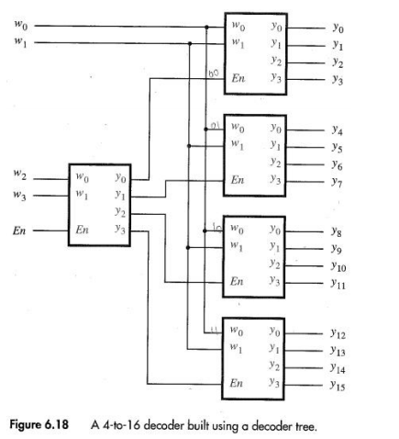

16. A combinatorial circuit is defined by the following three Boolean functions:

F1 = x’y’z’ + xz

F2 = xy’z + x’y

F3 = x’y’z + xy

Design this circuit with a decoder and external gates.

There are 3 inputs so lets use a 3-8 decoder. In F1, the first term corresponds to output line 0 of the 3-8 decoder (starting from 0 till 7). In F2, the first term corresponds to line 5. In F3, the first term corresponds to line 1.

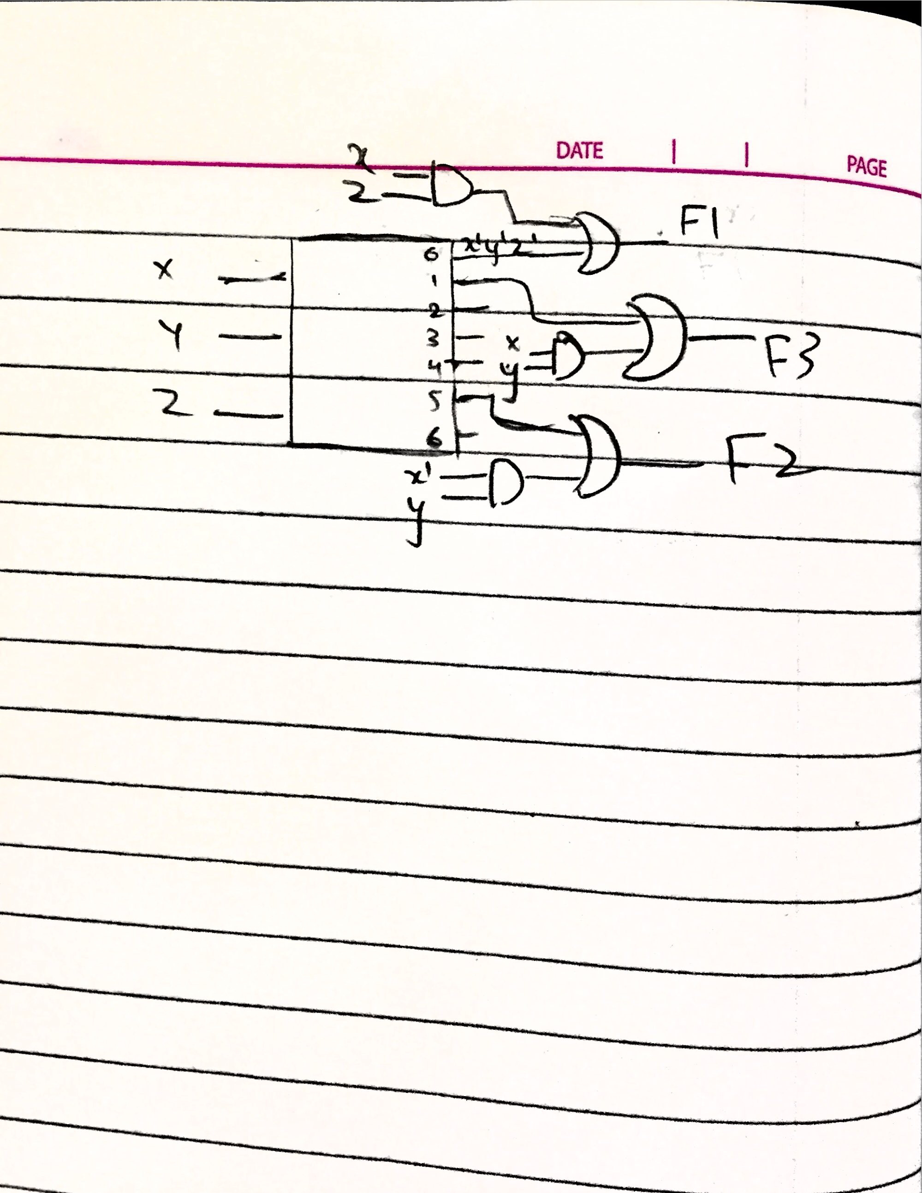

(Sorry for the bad drawing, the bananas are OR’s) lol

17. Construct a 16:1 multiplexor using two 8:1 multiplexors and one 2:1 multiplexor.

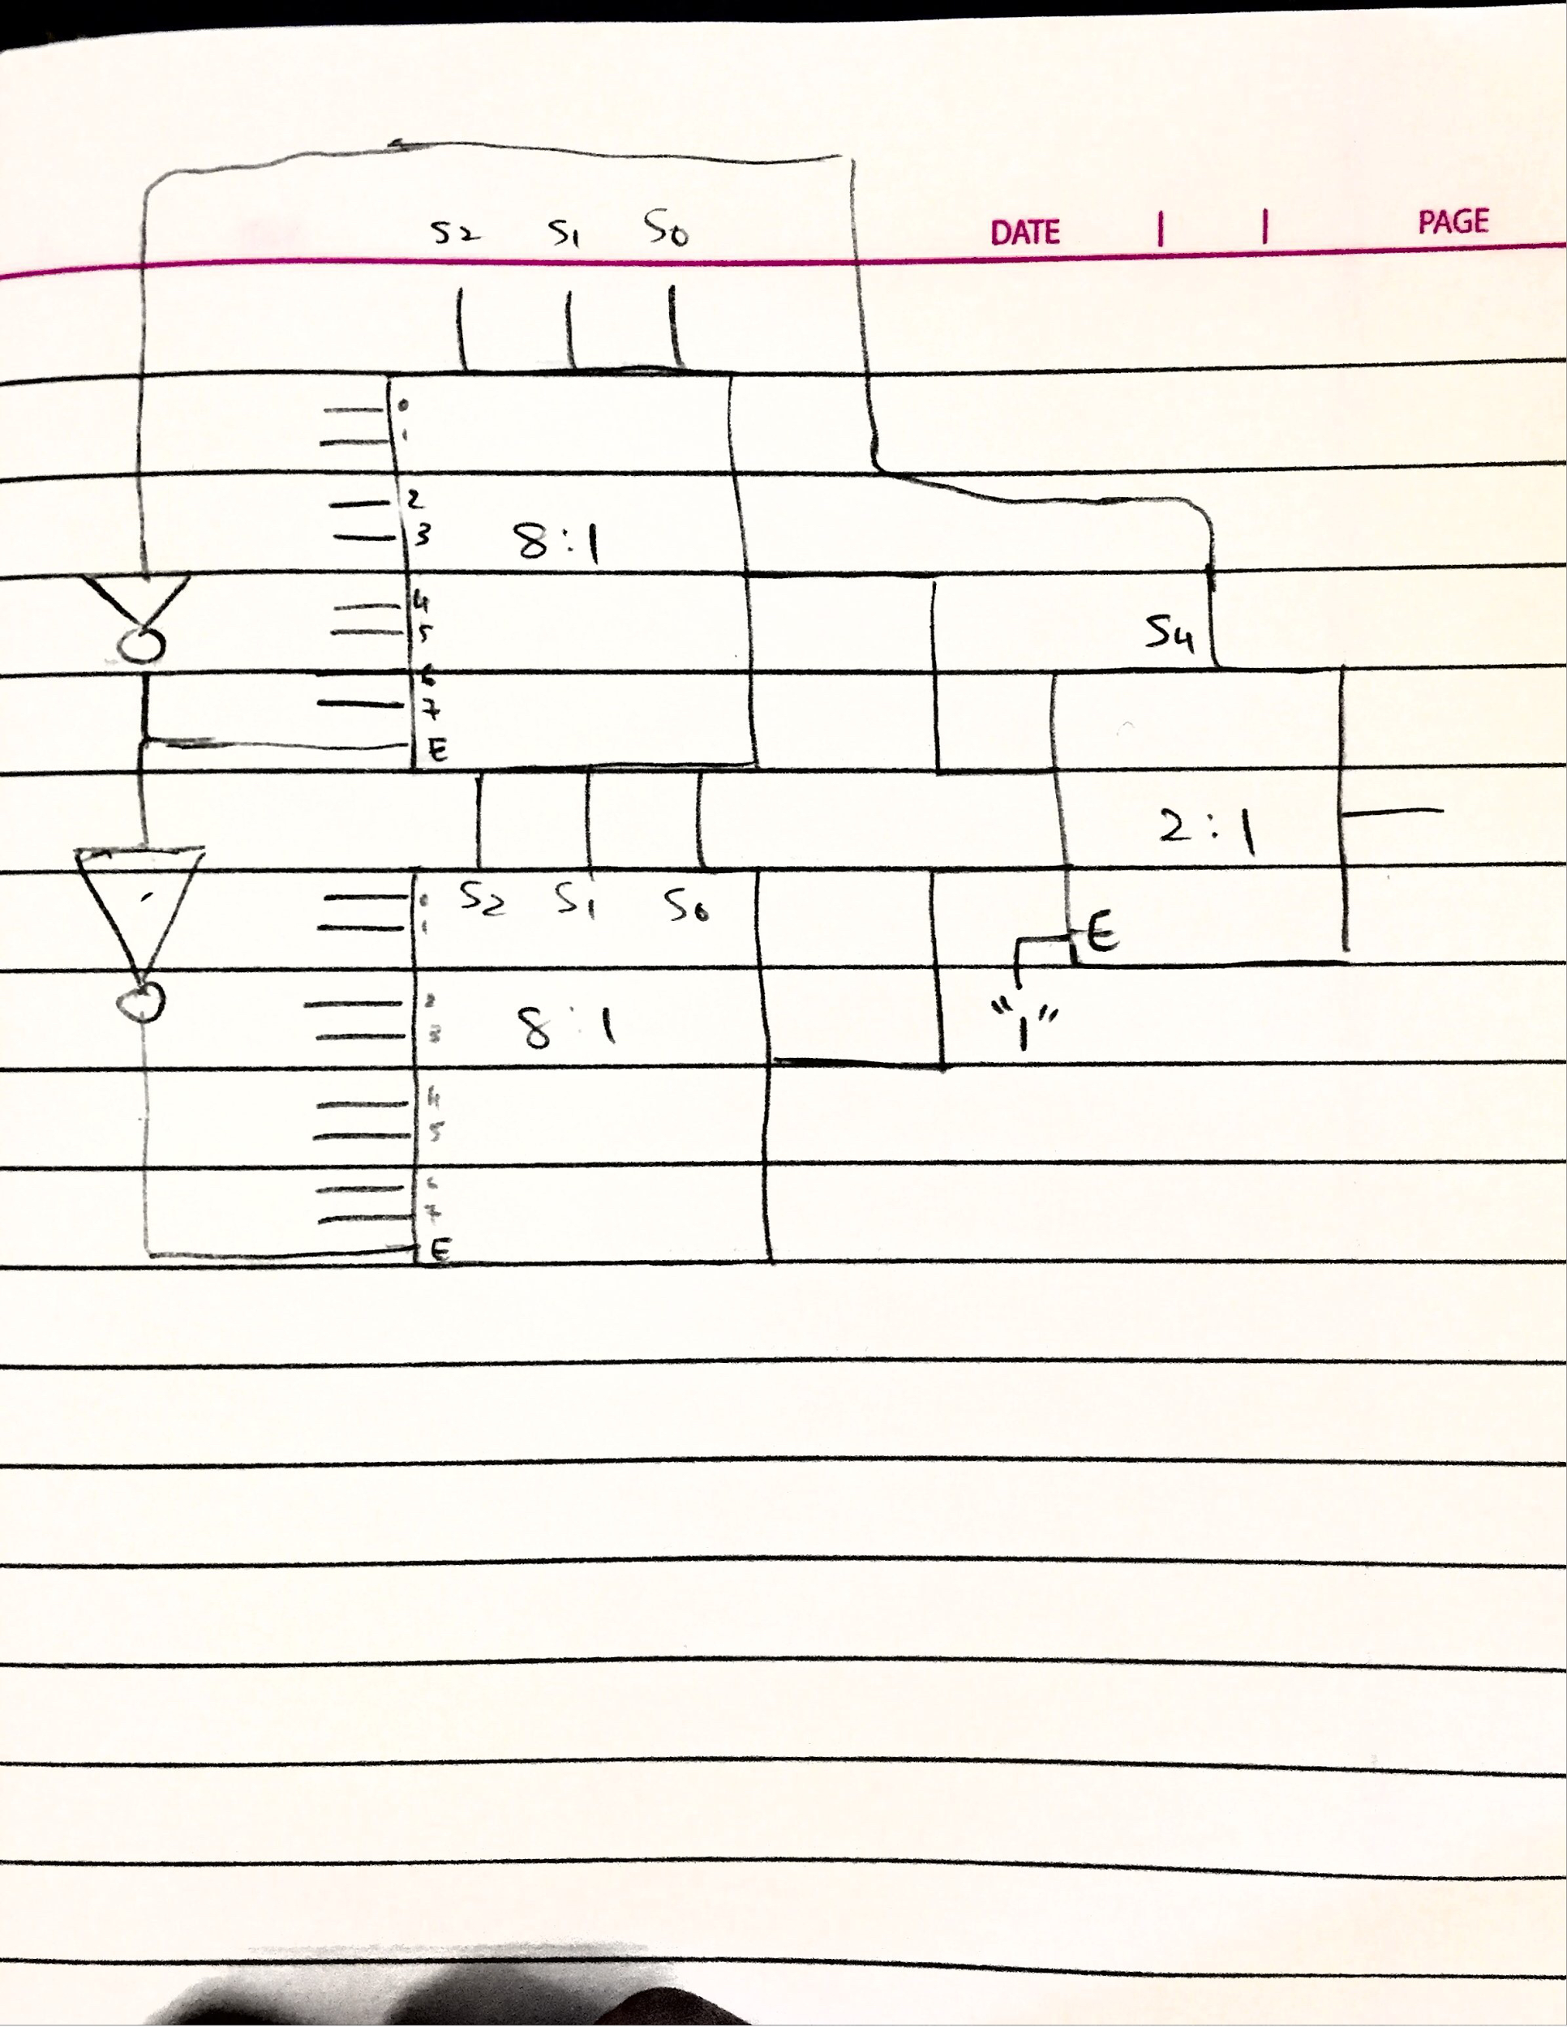

There are 4 select lines (S4, S2, S1, S0) (**I accidently labeled S3 as S4). Notice the fourth select line is used as the enable for the two 8:1 mux. With the inverters, this means that only 1 mux will be enabled at a time. For the first 8 inputs (0000 - 0111), the first 8:1 mux will be on. For the next 8 inputs (1000 - 1111), the second 8:1 mux will be on. S4 is also the only select line for the 2:1 mux, meaning when S4 is 0, it will only take input from the first 8:1 mux. And the opposite when S4 is 1 for the last 8 inputs.

(Sorry for the bad drawing)

(DM me for a more thorough explanation).

18. Implement the following Boolean functions with a multiplexor.

1. F(A, B, C, D) = **Σ** m(0, 1, 3, 4, 8, 9, 15).
2. F(A, B, C) = **Σ** m(1,2, 4, 5, 7)
3. Truth table

|  |  |  |  |  |
| --- | --- | --- | --- | --- |
| A | B | C | D | out |
| 0 | 0 | 0 | 0 | C’ + D |
| 0 | 0 | 0 | 1 |
| 0 | 0 | 1 | 0 |
| 0 | 0 | 1 | 1 |
| 0 | 1 | 0 | 0 | (C + D)’ |
| 0 | 1 | 0 | 1 |
| 0 | 1 | 1 | 0 |
| 0 | 1 | 1 | 1 |
| 1 | 0 | 0 | 0 | C’ |
| 1 | 0 | 0 | 1 |
| 1 | 0 | 1 | 0 |
| 1 | 0 | 1 | 1 |
| 1 | 1 | 0 | 0 | C + D |
| 1 | 1 | 0 | 1 |
| 1 | 1 | 1 | 0 |
| 1 | 1 | 1 | 1 |

A’B’

A’B

AB’

AB

A B

C

out

D

b. Truth table: stare at it until you see a pattern.

|  |  |  |  |
| --- | --- | --- | --- |
| A | B | C | out |
| 0 | 0 | 0 | 0 |
| 0 | 0 | 1 | 1 |
| 0 | 1 | 0 | 1 |
| 0 | 1 | 1 | 0 |
| 1 | 0 | 0 | 1 |
| 1 | 0 | 1 | 1 |
| 1 | 1 | 0 | 0 |
| 1 | 1 | 1 | 1 |

A’B’

A’B

AB’

AB

A B

C

1

out

4:1 multiplexor with A and B as selectors

19. Design a 4-bit prime number checker (i.e., output a 1 if the input binary string is a prime number; don't forget that 0 and 1 are also primes). Show the truth table, show the sum of products form, the product of sums form, and then implement the circuit using a single 8:1 multiplexor, and then with a single 4:1 multiplexor.

|  |  |  |  |  |  |
| --- | --- | --- | --- | --- | --- |
| Row | A | B | C | D | out |
| 0 | 0 | 0 | 0 | 0 | 1 |
| 1 | 0 | 0 | 0 | 1 | 1 |
| 2 | 0 | 0 | 1 | 0 | 1 |
| 3 | 0 | 0 | 1 | 1 | 1 |
| 4 | 0 | 1 | 0 | 0 | 0 |
| 5 | 0 | 1 | 0 | 1 | 1 |
| 6 | 0 | 1 | 1 | 0 | 0 |
| 7 | 0 | 1 | 1 | 1 | 1 |
| 8 | 1 | 0 | 0 | 0 | 0 |
| 9 | 1 | 0 | 0 | 1 | 0 |
| 10 | 1 | 0 | 1 | 0 | 0 |
| 11 | 1 | 0 | 1 | 1 | 1 |
| 12 | 1 | 1 | 0 | 0 | 0 |
| 13 | 1 | 1 | 0 | 1 | 1 |
| 14 | 1 | 1 | 1 | 0 | 0 |
| 15 | 1 | 1 | 1 | 1 | 0 |

8:1 (todo)

4:1

I_{0}

I_{1} F

I_{2}

I_{3} S_{1} S_{0}

A B

C

C’

D

C

D

20. Draw a logic gate diagram of the following function, using a minimal number of gates. F(A, B, C, D) = (((A' + B' + C)D) XOR (AB)') + (C'D')

Simplify using boolean algebra

isnt that the wrong answer? lol vvvvv

|  |  |
| --- | --- |
| Given | ( ((A' + B' + C)D) XOR (AB)' ) + (C'D') |
| De Morgan’s | ( (([AB]' + C)D) XOR (AB)') + (C'D') |
| Distributivity | ( (([AB]'D + [C]D) XOR (AB)') + (C'D') |
| definition of (a XOR b) = (a + b) * (ab)’ | ( (([AB]’D + [C]D) * (AB) ) + (C’D’) |
| Make more readable | (([AB]’D + CD) * AB) + C’D’ |
| Distributivity | [AB][AB]’D + [AB]CD + C’D’ |
| x * x’ = 0 | 0D + [AB]CD + C’D’ |
| x * 0 = 0, commutativity, associativity | [AB]CD + (D + C’D’) |
| a + a’b = a + b | [AB]CD + D + C’ |
| a + a’b = a + b | C’ + [AB]D + D |

A

B

C

D

21. Suppose that we want to construct an adder for two 64-bit numbers. If we use a ripple-carry adder, how many clock cycles does it take to produce the sum, the carry out, and the overflow flag?

If clock cycles = gate delays, and we treat each gate as taking 1 cycle to pass through, then there are at least 2 * 64 = 128 clock cycles to produce the sum and carry out. You only need to check for overflow once, so that makes 129.

22. Now suppose that we use a hybrid design. We perform carry lookahead on blocks of 8 bits, and then ripple the carry out signal among these 8 blocks. How many cycles are taken?

Every time you use CLA there’s just 3 gate delays. <<-- isn’t a CLA log(n) time complexity so wouldn’t it be log(64) *3? )) 128/8 = 16, and 16*3 = 48. But also add the RCA factor... it’s 16 times something... 8? <<-- if there is RCA between 8 blocks wouldn’t it 2 gates * 8? Not sure. So it’s 48 + 128? = 176? <<-- if CLA is log(n) then 64/8 = 8 blocks * log(8) because if each of the 8 blocks is 8 bits = 3*8 = 24 * 3 gate delays per block = 72, 72 + 2 gate delays * 8 blocks because the RCAs is between the 8 blocks = 88 for sum & carry out? maybe lol idk tbh.

23. What if, instead, we performed carry lookahead on blocks of 4 bits, and then rippled the carry out signal among 16 of these blocks?

24. Suppose we want to design a new latch, called set-dominate. It has a set (L) signal and a reset (M) signal as inputs. It differs from a conventional RS latch in the following way - simultaneously setting and resetting the latch (i.e., L=M=1) results in setting the latch so that it stores a 1.

a) Derive the excitation table for this latch.

b) Show how to design this latch using only a T flip-flop and any number of gates.

a)

|  |  |  |  |  |
| --- | --- | --- | --- | --- |
| Q(t) | Q(t+1) | L | M | T |
| 0 | 0 | 0 | x | 0 |
| 0 | 1 | 1 | x | 1 |
| 1 | 0 | 0 | 1 | 1 |
| 1 | 1 | x | 0 | 0 |

K-map

|  |  |  |  |  |
| --- | --- | --- | --- | --- |
| Q(t) / L(t)M(t) | 00 | 01 | 11 | 10 |
| 0 |  |  | 1 | 1 |
| 1 |  | 1 |  |  |

T(t) = Q(t) L’(t) M(t) + Q’(t) L(t)

T Q

L

M

25. Use the latch from (24) to and any combinational gates to design a JK flip flop.

Excitation table

|  |  |  |  |  |  |
| --- | --- | --- | --- | --- | --- |
| Q(t) | Q(t+1) | J | K | L | M |
| 0 | 0 | 0 | x | 0 | x |
| 0 | 1 | 1 | x | 1 | x |
| 1 | 0 | x | 1 | 0 | 1 |
| 1 | 1 | x | 0 | x | 0 |

L(t) k-map (error: **the k-map doesn’t match the excitation table above, 111 should be replaced with 100)**

|  |  |  |  |  |
| --- | --- | --- | --- | --- |
| Q(t) \ J(t)K(t) | 00 | 01 | 11 | 10 |
| 0 |  |  | 1 | 1 |
| 1 | x->0 |  |  | (x->0) |

L(t) = Q’(t)J(t)

M(t) k-map

|  |  |  |  |  |
| --- | --- | --- | --- | --- |
| Q(t) \ J(t)K(t) | 00 | 01 | 11 | 10 |
| 0 | x->0 | x->1 | x->1 | x->0 |
| 1 |  | 1 | 1 |  |

M(t) = K(t)

L

Q

M

J

K

26. Design a T flip flop using a JK flip flop and any number of gates.

Excitation table

|  |  |  |  |  |
| --- | --- | --- | --- | --- |
| Q | Q(t+1) | T | J | K |
| 0 | 0 | 0 | 0 | x |
| 0 | 1 | 1 | 1 | x |
| 1 | 0 | 1 | x | 1 |
| 1 | 1 | 0 | x | 0 |

J(t) = 1 k-map

|  |  |  |
| --- | --- | --- |
| Q(t) / T(t) | 0 | 1 |
| 0 |  | 1 |
| 1 | x->0 | x->1 |

J(t) = T(t)

K(t) = 1 k-map

|  |  |  |
| --- | --- | --- |
| Q(t) / T(t) | 0 | 1 |
| 0 | x->0 | x->1 |
| 1 |  | 1 |

K(t) = T(t)

T

J

K

Q

27. Design a D flip flop using a T flip flop and any other gates.

Excitation table

|  |  |  |  |
| --- | --- | --- | --- |
| Q | Q(t+1) | T | D |
| 0 | 0 | 0 | 0 |
| 0 | 1 | 1 | 1 |
| 1 | 0 | 1 | 0 |
| 1 | 1 | 0 | 1 |

D(t) = Q(t)T’(t) + Q’(t)T(t) = Q(t) xor T(t)

D

Q

T

28. Design a T flip flop using a D flip flop and any other gates. Compare to 27. Do you see anything interesting?

T(t) = Q’(t)D(t) + Q(t)D’(t) = Q(t) xor D(t)

Just switch the D and T in the above diagram.

29. A serial adder is a circuit that has two inputs (A and B) and an output (S). The inputs represent two binary numbers that have bit values that appear serially with the lowest significant bit first. The output is a serial sum of the two numbers. The diagram below shows the behavior of this circuit for two numbers: A = ...01101 and B = ...11100 and the sum is S = ...01001. Draw a state diagram for the serial adder.

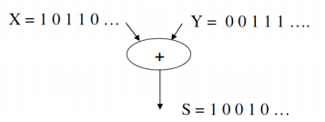

30. For (29), draw the circuit assuming that you have D flip flops and combinational gates.

31. For (29), draw the circuit assuming that you have JK flip flops and combinational gates.

32. Draw the state transition diagram for a finite state machine that has one input, which serially pushes bits. When the serial bits are divisible by 3, the output should show a 1.

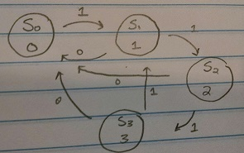

And also when S_{0} gets 0, it loops back to self.

33. Draw the circuit for (32) assuming that you have T flip flops and combinational gates.

4 states so 2 flipflops. [00, 01, 10, 11]. State transition table:

|  |  |  |
| --- | --- | --- |
| Present state (Q_a, Q_b) | Inp=1 Next State (Q_a, Q_b) | Excite input (T_a, T_b) |
| 0, 0 | 0, 1 | 0, 1 |
| 0, 1 | 1, 0 | 1, 1 |
| 1, 0 | 1, 1 | 0, 1 |
| 1, 1 | 1, 0 | 0, 1 |

T_a k-map

|  |  |  |  |  |
| --- | --- | --- | --- | --- |
| Input \ Q_a Q_b | 00 | 01 | 11 | 10 |
| 0 |  |  |  |  |
| 1 |  | 1 |  |  |

T_a = Inp * Q_a’ * Q_b

T_b k-map

|  |  |  |  |  |
| --- | --- | --- | --- | --- |
| Input \ Q_a Q_b | 00 | 01 | 11 | 10 |
| 0 |  |  |  |  |
| 1 | 1 | 1 | 1 | 1 |

T_b = Inp

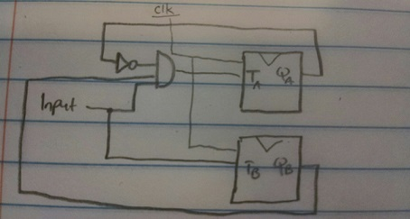

34. Draw a state transition diagram for a finite state machine like (32), except that the output shows a 1 when the serial input bits are divisible by 6.

35. Draw the circuit for (34) assuming that you have the reset-dominate latch from (24) and any combinational gates.

36. Name two levels of the memory hierarchy that are software controlled. Why are they software controlled, and what layer of software controls them?

1. The operating system controls what goes in and out of main memory from the disk.
2. The compiler controls what goes in and out of the register files from main memory.
   1. We need to make intelligent decisions about what goes in there, because the speed and capacity difference between the two components (Mem vs disk; Mem vs reg) is so large.

37. What are some rough access times (in clock cycles) and sizes of L1, L2, and L3 (LLC) caches?

1. L1 is 32-64KBs, access takes 2-4 CCs
2. L2 is 128-512KBs, access takes 8 CCs
3. L3 is 8-32MBs, access takes 32-50 CCs

38. Suppose you have the following loop: for (int i = 0; i < N; i++) a(i) = b(i) + c(i); Name two sources of temporal locality.

1. The variable “i” is used repeatedly
2. The instruction pointer/program counter, %eip, is repeatedly accessed for the loop

39. From (38), name four sources of spatial locality.

1. the array “a”
2. the array “b”
3. the array “c”
4. local variable: i

40. Suppose that you have a 32KB L1 cache, which is 2-way set associative. Suppose further that cache lines are 64 bytes. How many bytes are needed for your block 0offset, your index, and your tag? How many sets are there in your cache?

$$numsets = \frac{32 KB}{64B * 2} = \frac{2^{5}*2^{10}}{2^{6*}2} = \frac{2^{15}}{2^{7} } = 2^{8}$$

$$setindex = log_{2}(2^{8}) = 8 bits = 1 byte$$

$$blockoffset = log_{2}(64) = 6 bits$$

Assuming 32 bit addresses,

41. For the cache from (40), construct a memory reference sequence that suffers a cache miss every single time, assuming LRU replacement. Further, assume that to construct this memory reference sequence, you essentially loop through a set of memory references over and over. What is the minimum number of references required in this loop? Give an example of such memory references.

The minimum number is 3 because the 3rd memory reference will replace the least recently used before it can be hit.

To force a miss each time, make sure the set index # holds constant

0xABCD1234

0xAABC1234

0xBBCC1234

42. For the question from (41), if you have FIFO replacement, how many memory references are required in the loop?

3 as well. If each tag is unique, the first block will be pushed out of the set when the 3rd block is introduced.

0xABCD1234

0xAABC1234

0xBBCC1234

43. What if the replacement policy is random?

There is no minimum amount of memory references such that a miss is guaranteed for every reference in the loop because the replaced block could always be replacing the same block such that when the loop reiterates through the list, the other block is hit. Therefore, try to put as many such that the probability is low.

44. Suppose that you now have a cache hierarchy made up of a 32KB, 2-way set-associative L1 cache, and a 8MB L2, 8-way associative L2 cache. Further, assume that all caches have 64 byte lines, and LRU replacement. How many memory references are necessary in a loop, to cause all cache misses?

* We look at the cache with the largest associativity (in this case 8). Therefore, it must take 9 distinct references with LRU replacement. This way, the 9th reference will replace the 1st reference before the loop iterates again.

45. What is the difference between a set-associative, a direct-mapped, and a fully-associative cache? Which one typically has the highest hit rate? Which one typically has the quickest access time?

* Direct Mapped: A cache block can only go in one spot in the cache. It makes a cache block very easy to find, but it's not very flexible about where to put the blocks.
* Fully associative: No index is needed, since a cache block can go anywhere in the cache. Every tag must be compared when finding a block in the cache, but block placement is very flexible.
* Set associative: there’s two types → 2 way set associative and 4-way set associative
  + 2 way set associative: This cache is made up of sets that can fit two blocks each. The index is now used to find the set, and the tag helps find the block within the set.
  + 4 way set associative: Each set here fits four blocks, so there are fewer sets. As such, fewer index bits are needed.

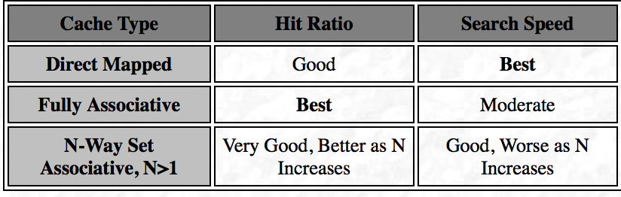

46. Suppose we now implement a cache policy that is the opposite of LRU - that is, you replace the most-recently used (or MRU) item. Construct a memory sequence - for the cache described in (44) - where MRU outperforms LRU.

Imagine you were looking up the details of buses as they arrived at a bus stop, based on their bus number (or whatever identifier you use).

It's somewhat reasonable to think that if you've *just* seen a number 36 bus, you're *less* likely to see another one imminently than to see one of the other buses that stops there.

Just one example, but the idea is more general: in some cases, having "just seen something" is a good indicator that you're *unlikely* to see the same thing again soon.

47. What is the difference between a write-through and a write-back cache?

When you get a “hit” on a “write” request, if you update main memory immediately, that’s write-through. If you instead set a “dirty” bit, which signals that you will write to main memory when that address gets evicted (in the meantime, there is a discrepancy between main memory and cache), that’s write-back.

48. Why do we maintain more than 1 byte in a cache block?

We maintain more than 1 byte in a cache block to take advantage of spatial locality. For example, when we access the first element of the array, we copy as many bytes of the array as can fit into our block for later.

49. What is meant by a demand fetch into a cache?

Demand-fetches have to do with temporal locality…

brings new memory locality into the cache when processor reference is not found in the cache; bringing an address into cache when first used

50. Random replacement is naturally not as good as LRU or FIFO, when it comes to hit rate. However, it does have one benefit - what is it?

no calculations required. uses less hardware